Online Voting system

Ferris State University

Alexzander Ealy

Contents

Memo to sponsor 3

Intro 3

Purpose 3

Overview of paper 3

Project Scope 3

Deliverables 3

Exclusions 3

Project Schedule 4

Project Budget 6

Risk Analysis 7

Project team 8

Task breakdown 8

Team composition analyst 9

Appendix 10

# Memo to sponsor

## Intro

Voting has always been slow, costly, and frustrating, but what if there was a way for everyone to vote at once and results be tallied up on the spot. In comes the idea of online voting. Many people have talked about the idea of online voting, and some of the big problems like the potential for hacking the server or people not having access to internet have been the biggest pushbacks to going online, but with the advent of better security like public and private keys and the ever-expanding internet. The benefits outweigh the costs and risk associated with online voting.

## Purpose

This plan purpose is to explain how a project about an online voting system might be scheduled, what risk might happen, the budget needed, and what kind of team is needed.

## Overview of paper

This paper starts with the scope of the online voting system, then talks about an initial WBS, then as more was found out there is a more detailed WBS. After that there is break down of the budget, did not show the initial budget because it is the same, and then it is finished off with deep team analysis.

# Project Scope

## Deliverables

This system will run on both mobile and desktop users and will be accessible through a website to migrate how much space is needed to vote and allow it to work on a variety of platforms. There will be some form of identification; to prevent fraud. There will be some manual way of undoing a vote if someone’s account is compromised. The system will only track that someone voted and not who they voted to keep voters anonymous. Lastly, the system should be portable so that it can be sold as a service to other townships for another revenue source.

## Exclusions

This system will not register voters, count votes casted from other sources, or be useable for a national election.

# Project Schedule

Initial Work break down structure

|  |  |  |
| --- | --- | --- |
| Name of Milestone/Phase or Key Task | Description | Target Date have it done by |
| Project Kick off | Begin designing and planning out the system. | 09/14/2020 |
| Create a blueprint of a tally system | Begin mapping out how the system will count/collect votes and keep track of said votes. Not actually creating it but more like we think we will have a form of some sort on a page and use some code to store it on some device. | 09/14/2020 |
| Create a blueprint of a voter verification system | Come up with an idea of how we plan on verify a voter automatically over the internet. | 09/15/2020 |
| Create webpage layout | A basic wire diagram of how content will be laid out on the webpage. | 09/18/2020 |
| Start creating the tally system | Taking the blueprint and turning it into an actual working system | 09/15/2020 |
| Finish the tally system and create the voter verification system | Taking the blueprint/idea and turning it into an actual working system. Along with finishing the tally system | 11/15/2020 |
| Start testing the Tally system | Running test on the tally system and ensure that it doesn’t say you voted for person A if you clicked B and that the count is displayed within 3 hours after voting closed. | 11/20/2020 |
| Start testing the voter verification system and fixing the bugs found in the tally system | Start running test on the verification system and ensure that it is working, and that its protected against fraud, and then implement fixes for any bugs found in the tally system | 12/01/2020 |
| Implement both systems, and fix any bugs, then go live | Put both systems in and more testing, fixing any bugs found, and repeating it till no more bugs can be found. | 02/01/2020 |

The start initial WBS gives a good blueprint that was then used to make the full WBS. Some key things to point out, A lot of the time is spent on the execution, and controlling and monitoring phases instead of planning, or implementing because it is hard for us to test a system, that is not made, and we do not want to spend a lot of time implementing a system that does not work. This is a six-month project and any delay in planning or creating the tally system or implementing will put us behind schedule. We can not afford to be behind schedule as the due date is a hard-set March 1st, 2021 for that’s when the election happens, if there is a delay in one of those sections, then we will have to hire outside help to hit our mark.

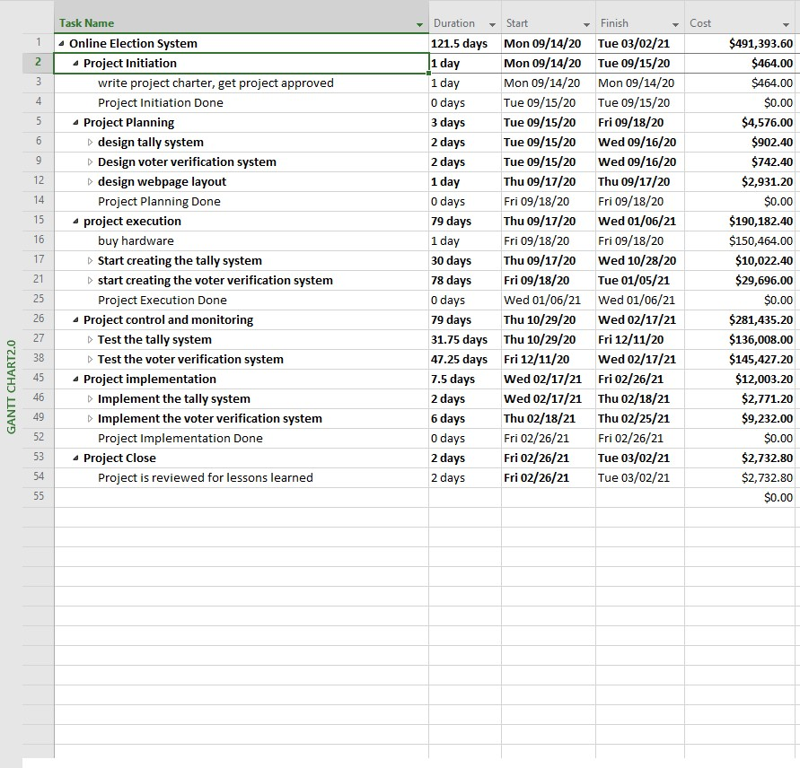

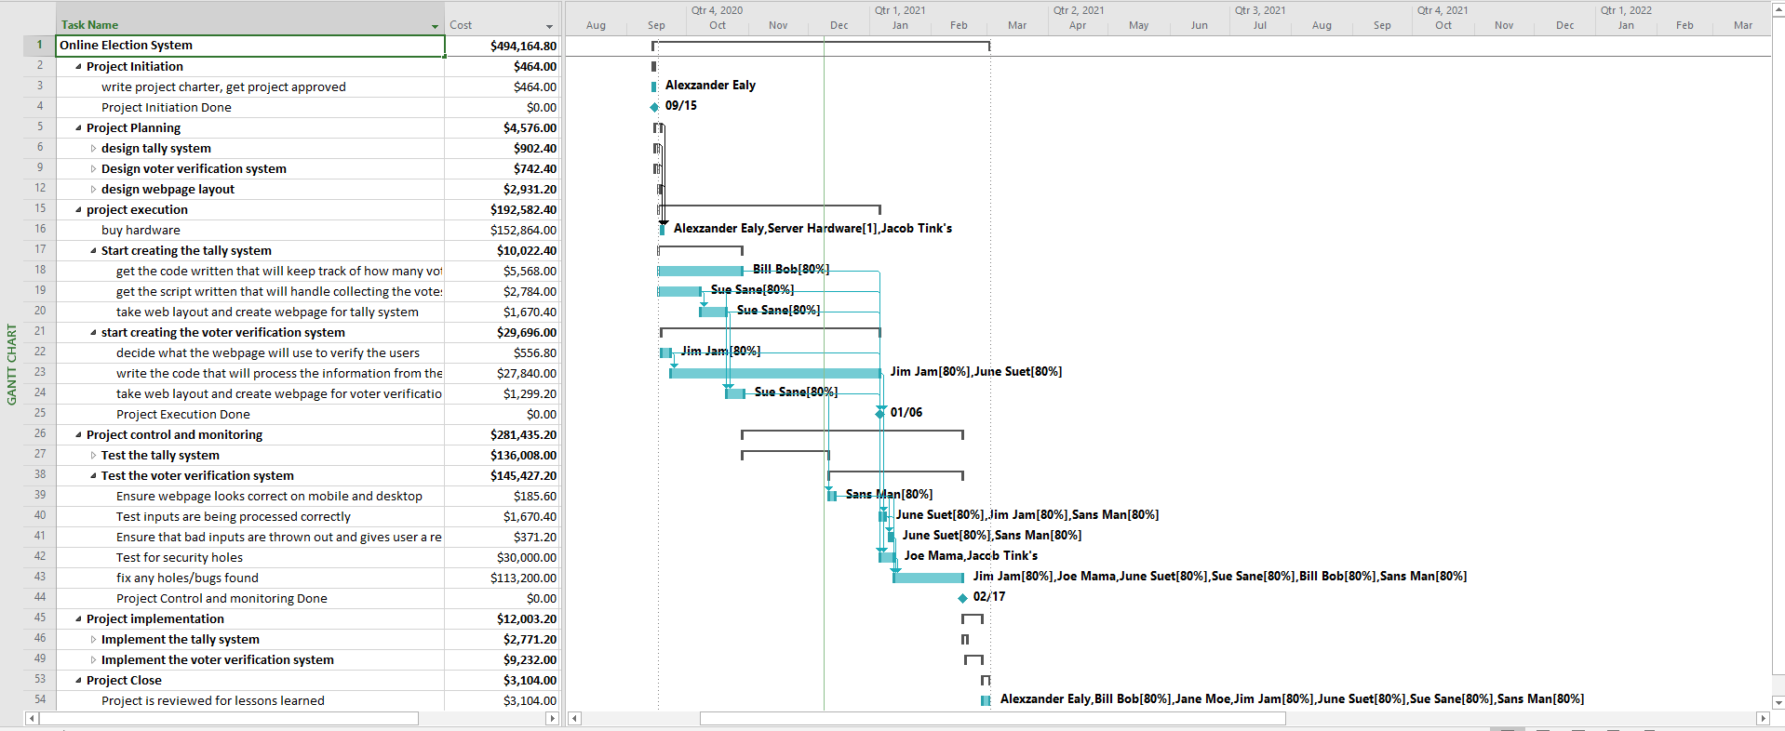

Shows a breakdown of tasks and who will do what along with major milestones.

# Project Budget

As was said earlier, most of the team’s time will be spent in executing the project and controlling/monitoring the project which makes up a 75%+ of time spent (see figure below), and about $450,000. Those areas are not only costly due to the time spent but also because of contracting a network admin who will be qualified for a project of this caliber, and the penetration tester who must be the best of the best. Any breaks or holes in the system will make this project a fail. $150,000 Of the $450,000, is used on hardware which the system will run off. Below are some graphs which help break down where the money is spent, and how much time is spent in each phase of the project group by summary tasks.

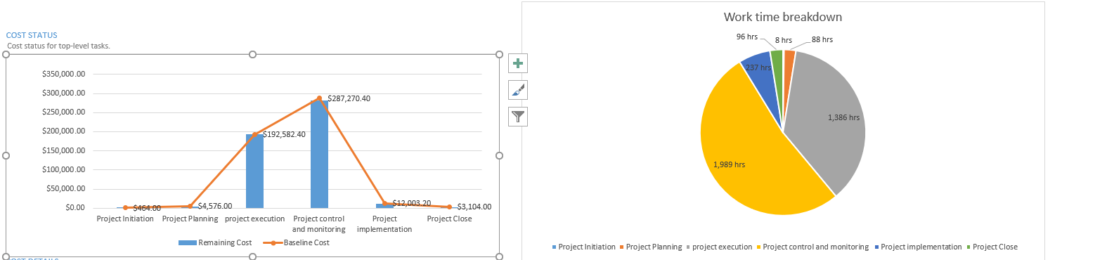

# Risk Analysis

Initial risk

|  |  |  |
| --- | --- | --- |
| Risk Description | Probability that risk will occur (high, med, low) | Impact on the project if risk occurs (high, med, low) |
| The system falsely verifying a person. | **Low** | **Low** |
| The data on the server becoming corrupted. | **Med** | **High** |
| The server getting hacked | **High** | **High** |
| The server crashing (as in needing a reboot due to an overload) | **Low** | **Med** |
| The server getting destroyed by natural causes (township is in California). | **Med** | **High** |
|  |  |  |

Above is some of the initial risk where things like physical damage to the server and crashing as time went on and more knowledge came about, we decided to focus on new risks. Below are all the risks the team decided were the biggest risks that should be focused on. Some key risks are data leaking who voted for who, or voter fraud both of which would invalidate the election. Both of which can be migrated by hiring qualified people, who can test the system for leaks, and design a system that prevents voter fraud. Find the full Risk Register in the Appendix.

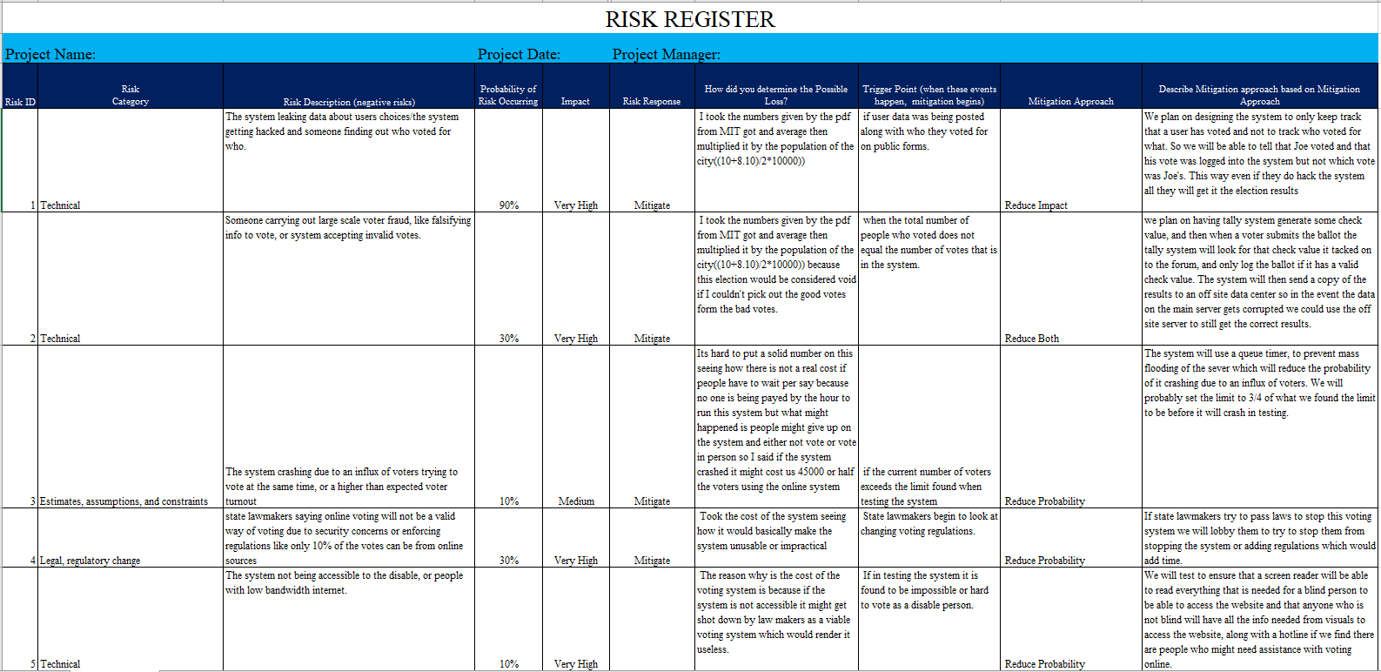

# Project team

## Task breakdown

The RACI helps show who will be doing what, and who should be consulted on when changes are made or who should be informed. Some key notes would be the software development team needing to be consulted and informed when ever a change is made and bringing in specialists during the design phase to help curb failure due to non-conformity.

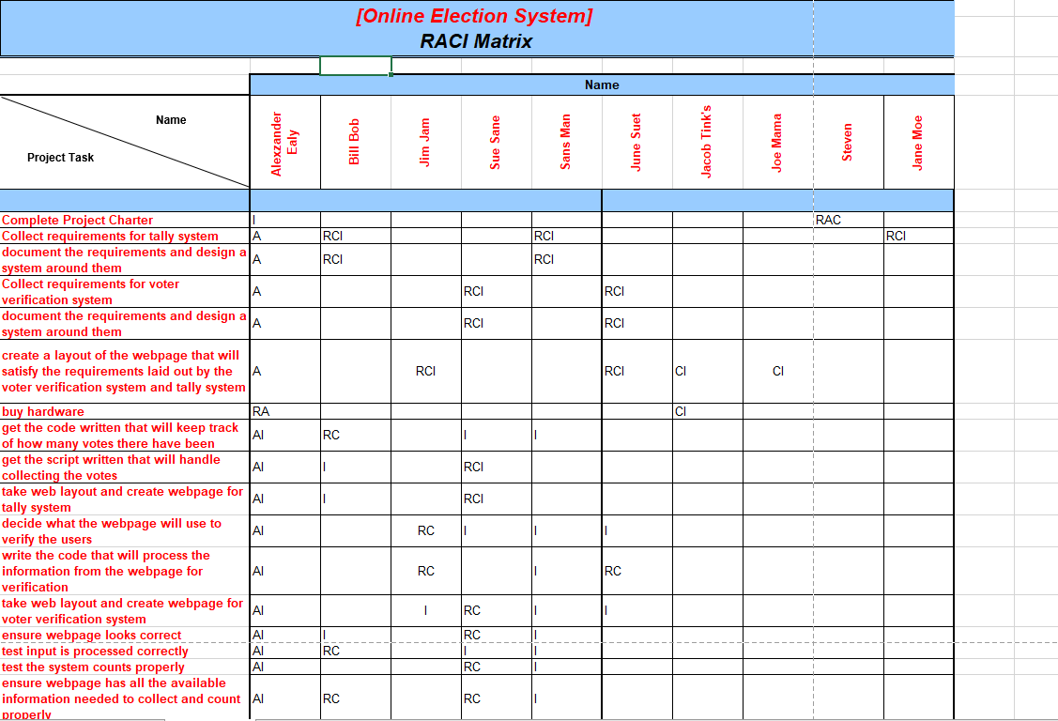

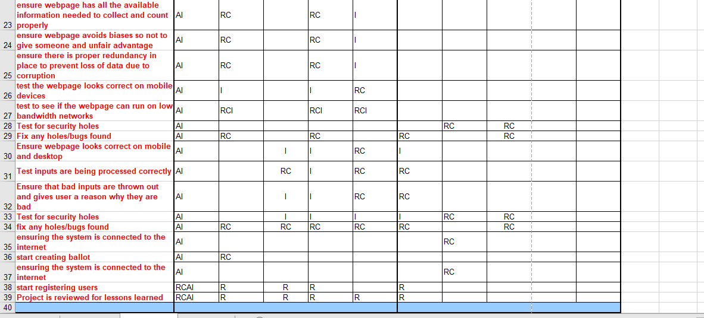

## Team composition analyst

The team is made up of 5 software developers, 1 network admin, 1 penetration tester, and 1 compliance officer. Below is a chart diagramming who has a a lot of power or ability to tank the project and then there is influence which how likely are they to use their power if things do not go their way. The common theme is if they are the only ones doing something in a project then they have high power and influence due to not having to rely on someone else to tank the project and because there is no one who can take their place verse other people who may be make up a team like the software developers.

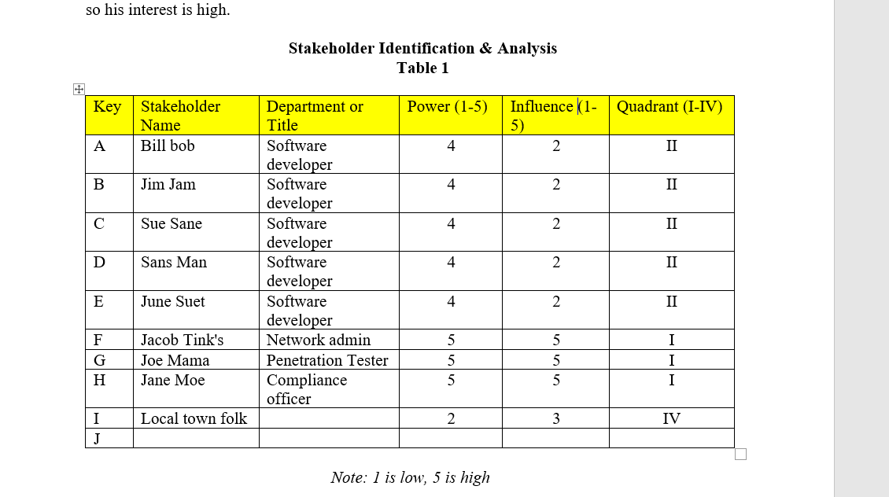

This chart below shows who should be watched closely to ensure they are not making mistakes, and that they aren’t going to tank the project, once again those who are most likely and can tank a project are managed closer than those who are less likely the tank the project but still could.

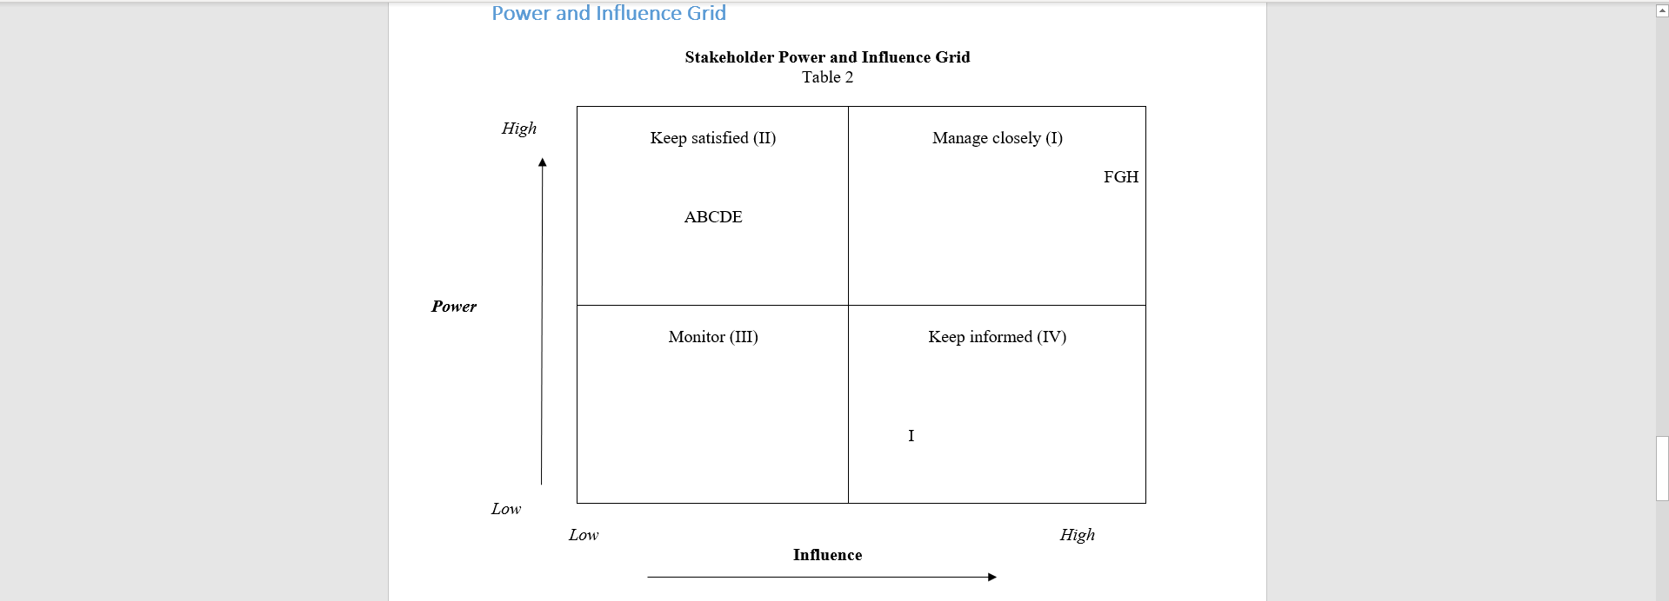

Lastly is a table showing where the stakeholders are currently and where they should be to ensure a successful project. For the most part those who have high power and influence need to be leading and going above and beyond just doing what is told to ensure that the best possible system is made, whereas those who have little influence but high-power need to just kind of support the project and do what is asked. The game plan to get them to their current level is good management and clear guidelines along with a high salary, and then for those who need to support it, just giving them a good manager and tying in this project with their performance review.

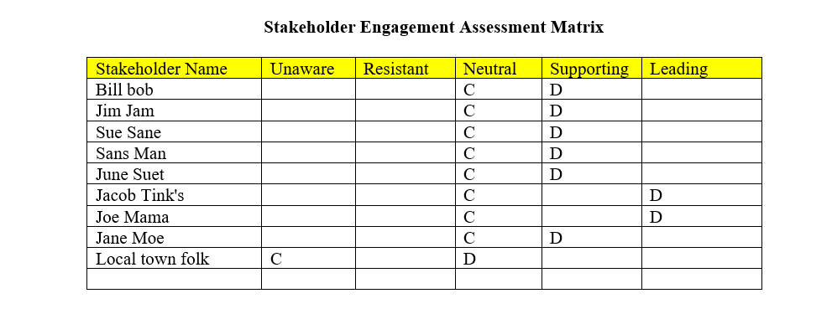

# Appendix

